|  |  |  |
| --- | --- | --- |
|  | |  |
|  |  |  |
|  |  |  |

|  |  |  |  |  |  |  |
| --- | --- | --- | --- | --- | --- | --- |
| Lab Manual Handout  Electric Circuits EE (100)   |  |  | | --- | --- | | Name | Muhammad Asad | | Reg. No | 2019-EE-383 | | Marks/Grade |  |     EXPERIMENT NO. 11  MAXIMUM POWER TRANSFER THEOREM  Objectives:  To   verify that maximum power will be delivered to the load when load resistance is equal to the total equivalent resistance of the circuit.  Equipment:  Resistors  DMM  Breadboard, DC power supply Connecting wires  Prerequisite:  Before coming to the lab, students must study and practice the Maximum Power Transfer theorem, and also review other circuit analysis techniques.  Theory Overview:  Consider the fig. 1 1.1 shox',n belo»,    Figure 11.1: A linear two-terminal Thevenin equivalent circuit  If the entire circuit is replaced by its Thevenin's equivalent circuit except for the load, the power delivered to the load is  Pi = Ž2Rt =  (1 1.1)  Page 1 of 4  Engineering  Department  UET  Electrical  Fsd. |

Electric Circuits EE (100)

Observations:



# RTH=

Lab Manual Handout ft 11

|  |  |  |
| --- | --- | --- |
| Load resistance | Currentflowing through circuit | Power delivered to the load |
|  |  |  |
|  |  |  |
|  |  |  |
|  |  |  |
|  |  |  |
|  |  |  |
|  |  |  |
|  |  |  |
|  |  |  |
|  |  |  |
|  |  |  |
|  |  |  |
|  |  |  |

Table 11.1: Data to test the validity of Maximum Power Transfer theorem

Electrical Engineering Department UET Fsd.

Page 3 of 4

Electric Circuits EE (100) Lab Manual Handout g Il

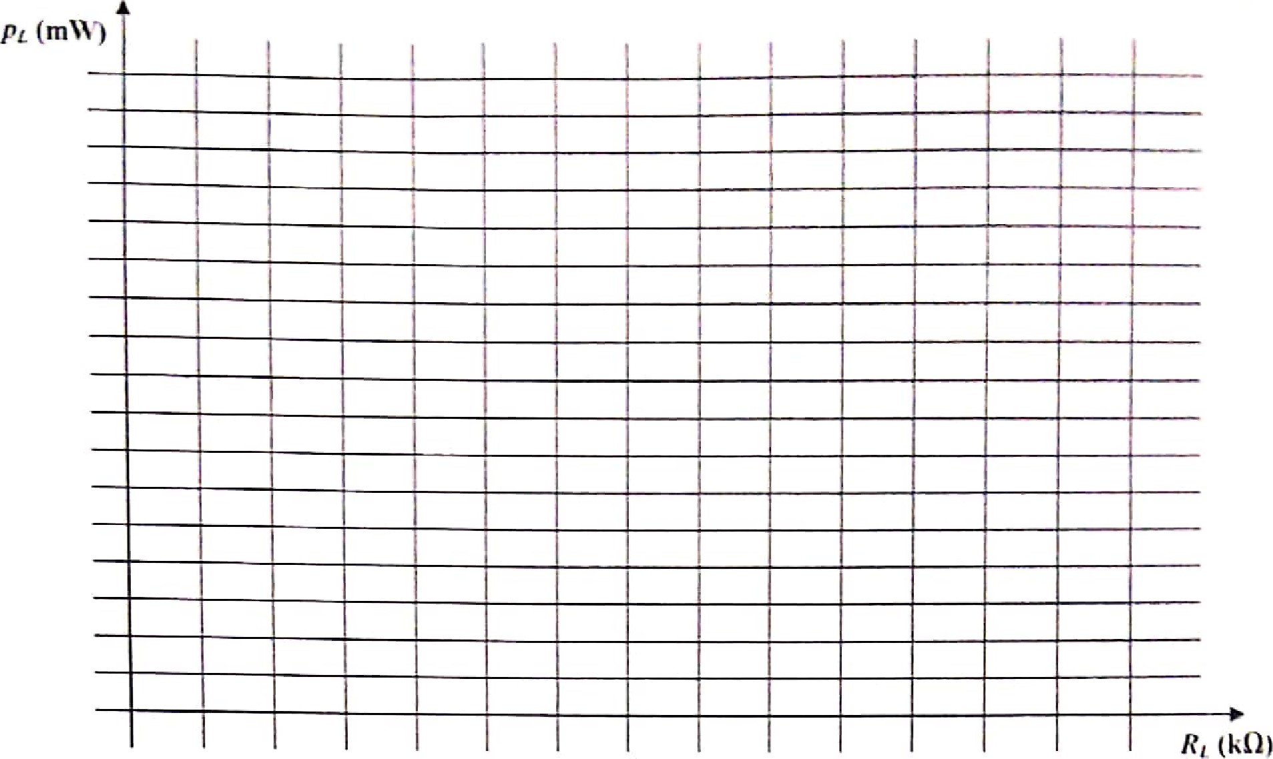

Figure 11.3: Power delivered to the load vs. the load resistance Questions:

l. Using elementary calculus, determine the expression for the load resistance RL(Eq. 1 1.2) so that maximum er is transferred at the load terminals?



2. Find the value of RL for which the maximum power will be delivered to the load. Also tind the value of maximum power that is delivered to the load.

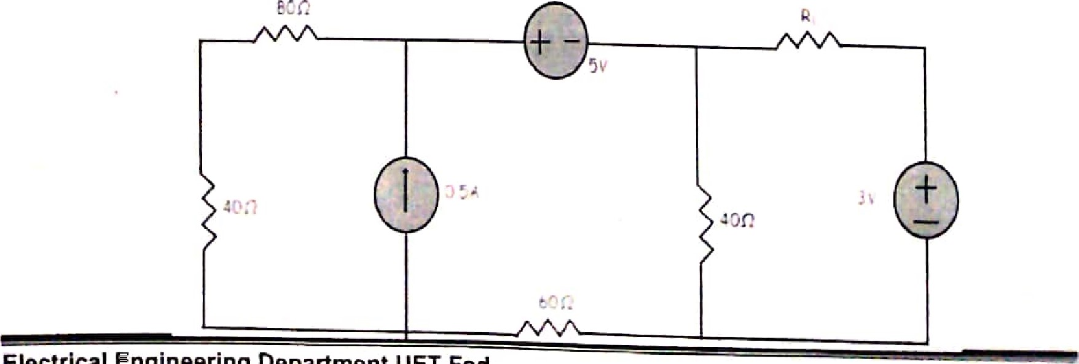Electrical Engineering Department I-JET Fsd.

Page 4 Of 4



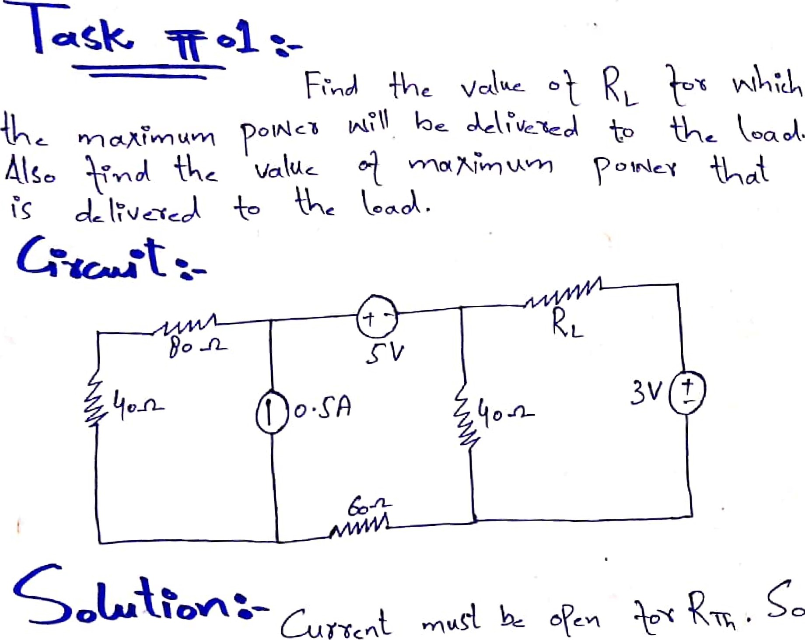

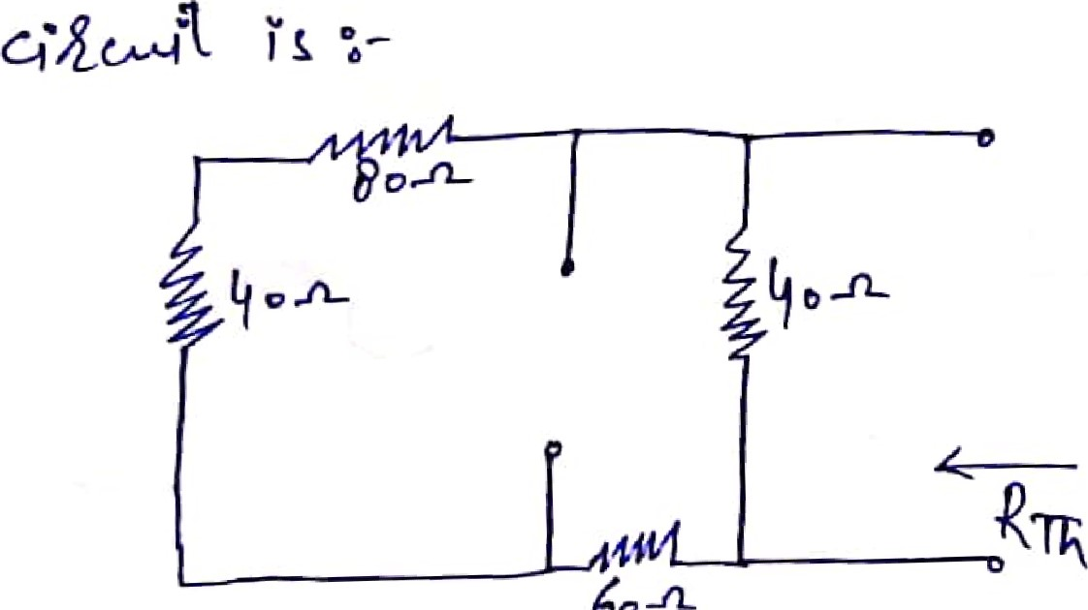

60

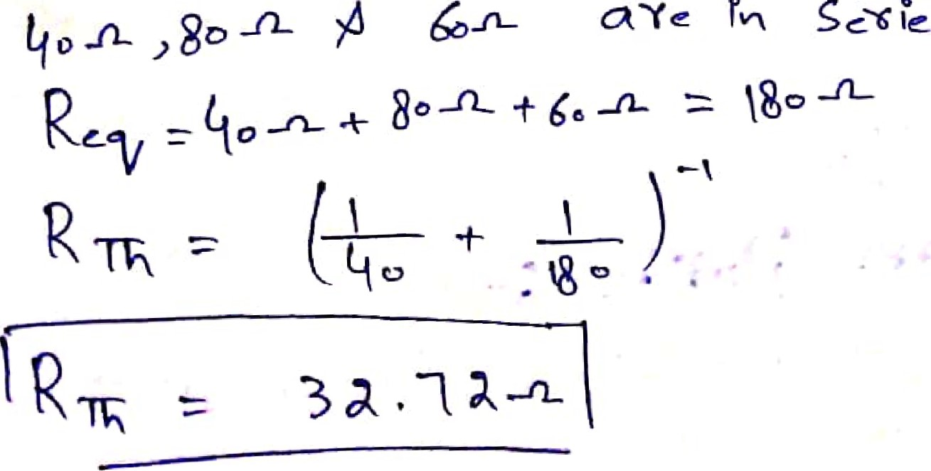g o

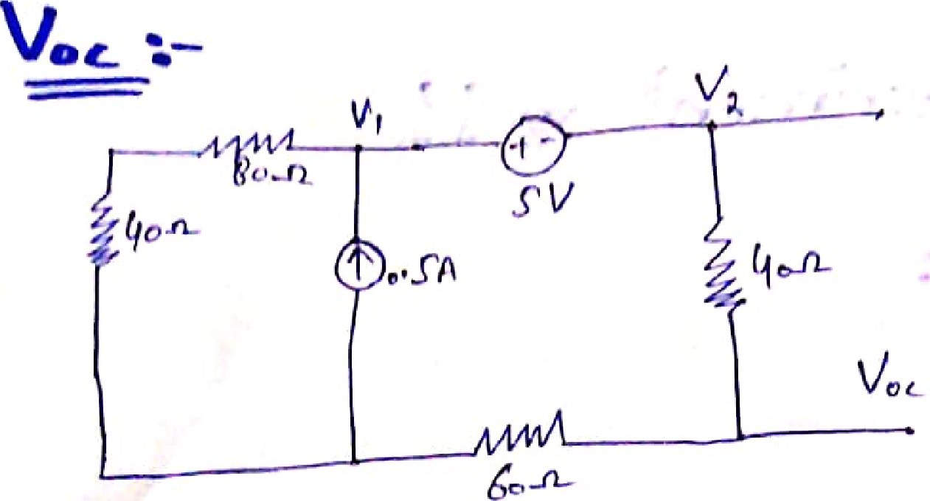



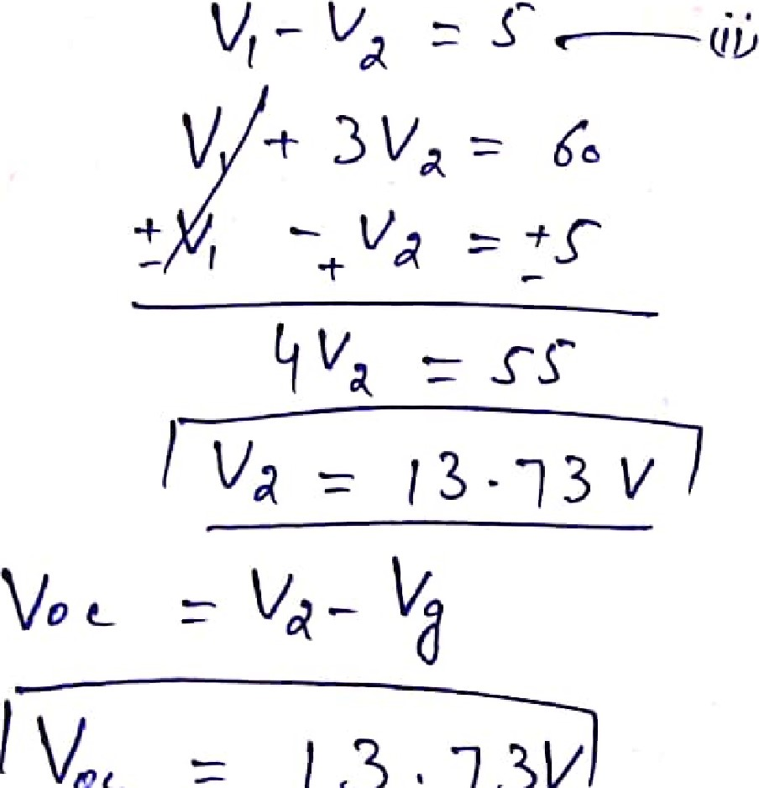

V

oc

3

,

73b

/

1

RTA = RL



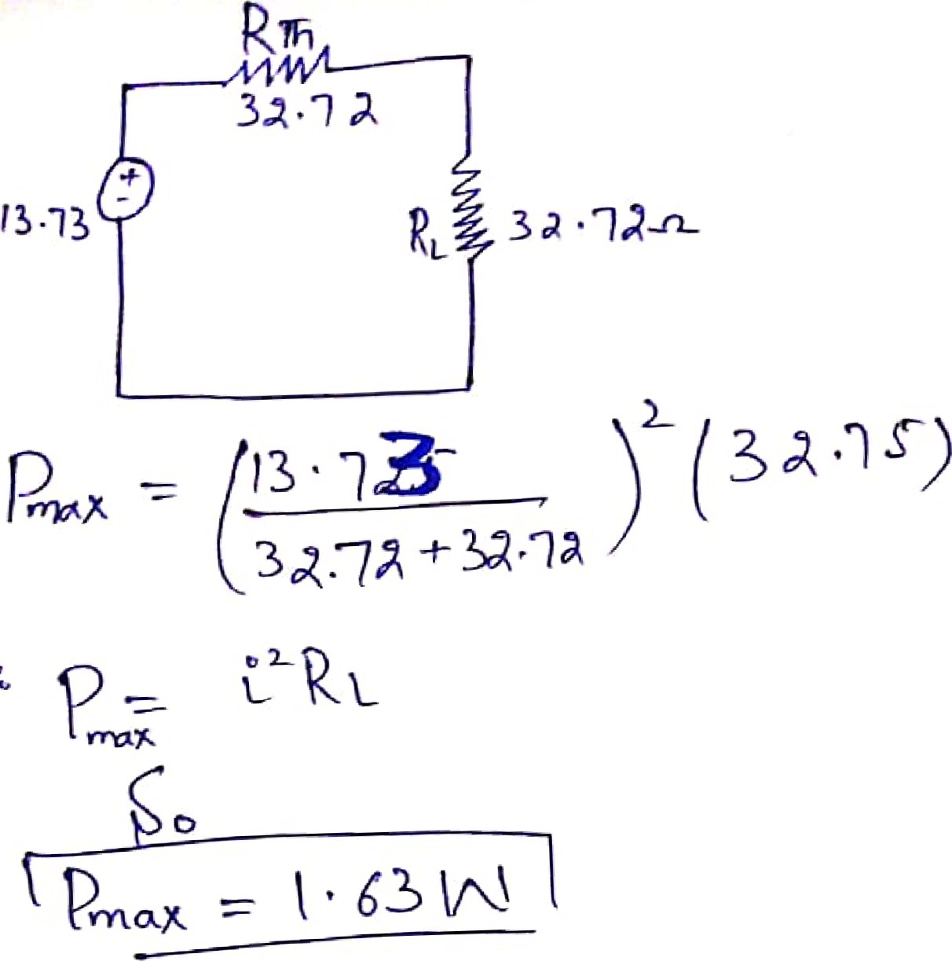

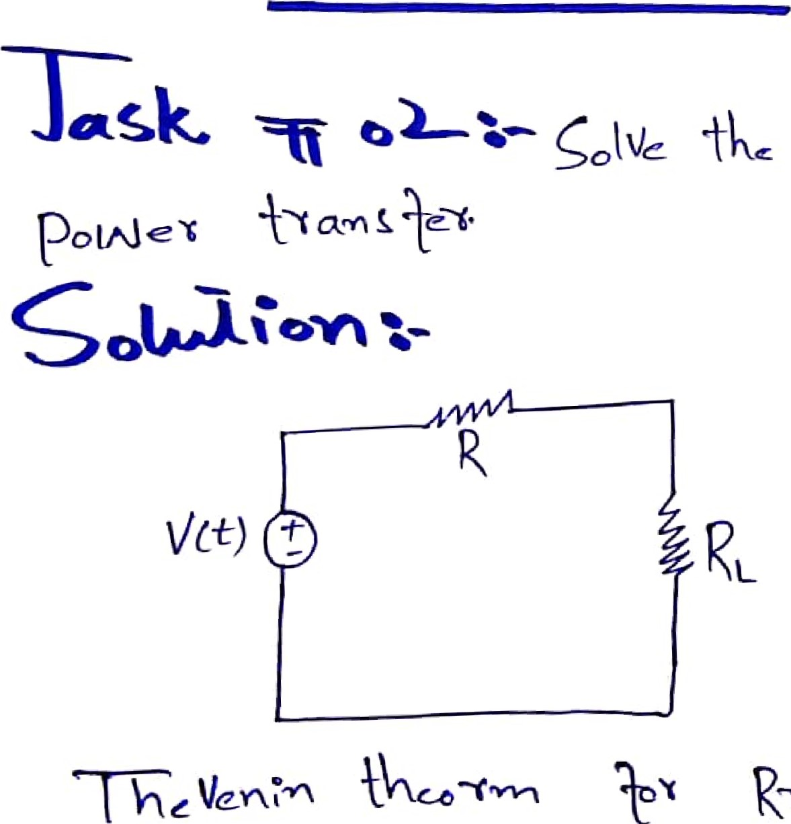 cX/Lc04Þt

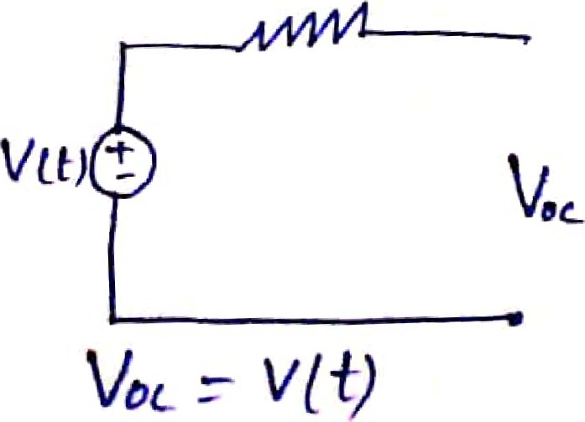

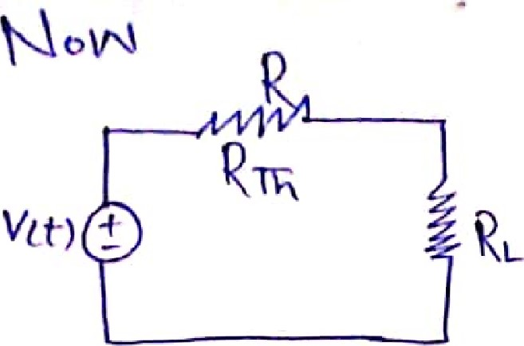

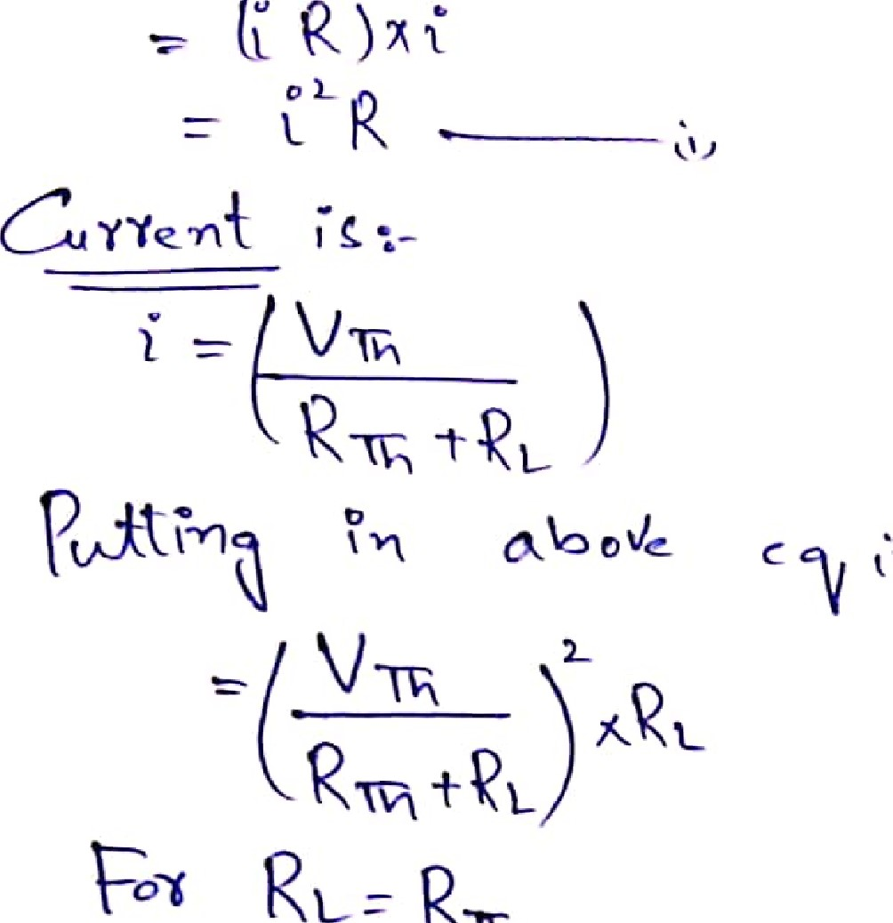

RTR

p = (VIA )

